**Output waveform on Running Testbench:**

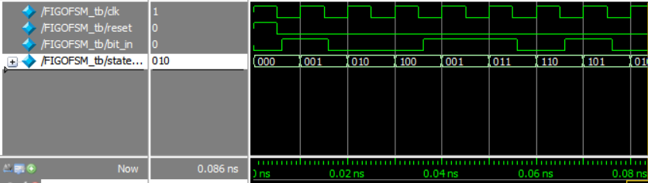

**Pin Planning:**

**Switch allocation:**

Switch 0: bit_in

Switch 1: clk

Switch 2: reset

**Output LEDs:** LED[2], LED[1], LED[0]